
The Surrey Hills Society
Warren Farm Barns
Headley Lane
Mickleham, Dorking
RH5 6DG
Voicemail: 01372 220647
Mobile: 07530 949302
info@surreyhillssociety.org

MAP READING TO ENJOY THE SURREY HILLS
Sunday 14th May 2017
10.00am – 3.30pm

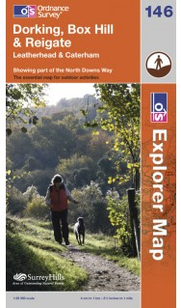
This is a training day for those who want to get out and appreciate the Surrey Hills, but do not have the confidence and experience to use Ordnance Survey maps and a compass. This session will go through basic skills suitable for use in the Surrey Hills, but will not take you to a level suitable for navigation in remote and wild country.

The morning session will be indoors, learning about the features used on the Ordnance Survey Explorer map series and the basic use of a compass. After lunch we will head outdoors for a practical session relating the map to the surrounding landscape. This will involve short walks between areas providing good viewpoints of the surrounding area, with small group work to relate the map and compass to the landscape.

This event will not be suitable for children under 10 or pushchairs. During the afternoon session, we will be walking a short distance along possibly muddy footpaths, to gain good vantage points of the surrounding area. This event is not suitable for dogs.

The session will start at 10.00am for coffee and biscuits with the training session starting at 10.15am. We will break for lunch 12.30pm – 1.15pm. Soup and a roll will be provided, but please feel free to bring additional food if you wish. We will be back at the hall by 3.00pm for a cup of tea and any final questions, finishing by 3.30pm.
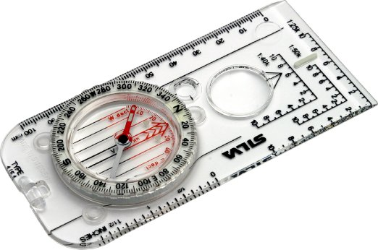
Venue: Wonersh. Full joining details will be sent with booking confirmation

Booking is essential to assist catering. Please bring a notebook and pencil and wear appropriate clothing and footwear for winter conditions outdoors.

The cost for the day will be £12 for members and £14 for non-members. A copy of Ordnance Survey Explorer Map 145 (Guildford & Farnham) and a basic compass, are required for the session (can be shared between two). These can be purchased from Outdoor shops, booksellers and Amazon. Note that the compass should be calibrated with 360 degrees around the dial (as shown above) and not any other notation.

Please enclose your e-mail address OR a stamped addressed envelope for confirmation of your booking.

For further details and enquiries, contact us at info@surreyhillssociety.org or on mobile 07530-949302.

Please return this slip to:
SHS – Map Reading, Warren Farm Barns, Headley Lane, Mickleham, Dorking, RH5 6DG

MAP READING TO ENJOY THE SURREY HILLS
Sunday 14th May 2017
10.00am – 3.30pm

I wish to book ______ member places at £12 per person and/or______ non-members at £14.

I enclose a cheque for £ _______________ payable to “The Surrey Hills Society” and a stamped addressed envelope (if no e-mail address available).

NAME(S) …………………………………………………………..……… MEMBERSHIP NO. ………………

ADDRESS …….…………………………………………………………………………….…………………….…

……………………………………………………………….…….. POSTCODE ………………………………..

Telephone ………………………………….. E-mail ………………………….…………………………………..

Date ……………………………………….. Signed ……..……….………………………………………………

NAME(S) of other applicants (if more than three, continue below):

NAME ……………………………….…………………………………………MEMBERSHIP NO…………….

NAME ………………………………………………………………………… MEMBERSHIP NO…………….

NAME ………………………………………………………………………… MEMBERSHIP NO…………….

DIETARY REQUIREMENTS ….……………………………………………………………………………….…

Please note that the Surrey Hills Society and its Event partners accept no responsibility for any loss, damage or personal injury during events. Participants are requested to wear appropriate clothing and footwear and take due care and attention.
The Society uses members’ photographs on social media and on our website. If you are not happy to have your photo taken during this event, please notify us in writing prior to the event and make the event organiser aware on the day.

