
The Surrey Hills Society
Warren Farm Barns
Headley Lane
Mickleham, Dorking
RH5 6DG
Contact telephone: 01372 220647
info@surreyhillssociety.org

Chairman’s Day – Behind the Scenes in Guildford
Explore Historical Guildford and its hidden treasures
Wednesday 21st June
10 am to approximately 3 pm

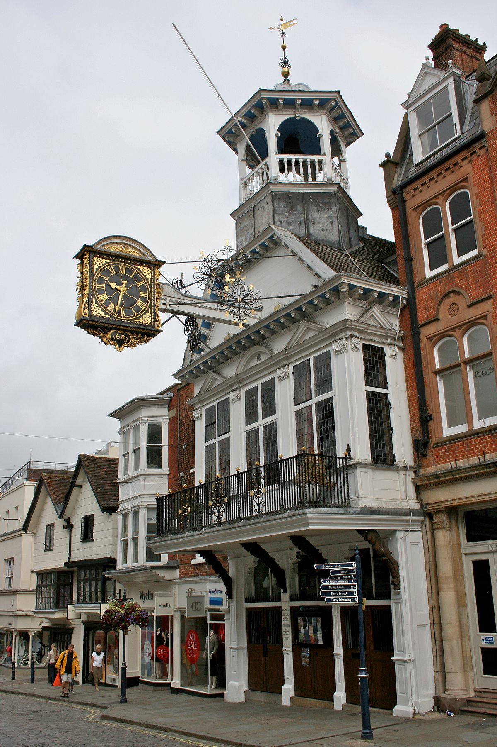
Join the Chairman of the Surrey Hills Society on a special behind the scenes look at the historic town of Guildford. The day will include fascinating visits to key historic buildings of the town.

After coffee and a private tour of the fabulous Guildhall, we will meet some of the key people who manage the town and get a better understanding of how the town functions. Town Guides will then lead the group on an intriguing tour of the hidden treasures of the town. The tour will include a visit to Guildford Castle, and the medieval Undercroft in Guildford’s High Street. This is one of the finest examples in the country and believed to date from the 13th century. Undercrofts are usually associated with towns engaged in import and export of luxury goods. You will also learn about some of the interesting characters from history that called Guildford home, including Lewis Carroll, Alan Turing (who broke the Enigma Code during World War 2), former Archbishop of Canterbury, George Abbot, and the birthplace of author P G Wodehouse.

A private lunch will be served back at the Guildhall, where Cllr Gordon Jackson, recently retired Mayor of Guildford will join us and tell us about his year as Mayor, supporting the Surrey Hills Trust Fund.

After lunch we will visit Abbots Hospital, the oldest “hospital” or place to care for the elderly of the area, still in its original use. Dating from 1619 it continues to offer town centre accommodation within a sociable and supportive environment for local elderly people.
We will also have a guided afternoon tour of the beautiful Guildford House Gallery. This is one of the oldest buildings in the tour which now houses a public art gallery.

Afternoon tea will be served at the Guildhall to finish our memorable day.

The cost for the entire day will be £30 for members, and £35 for non-members, which includes coffee on arrival, entrance fees and guided walk fees, lunch and afternoon tea.

Booking is essential: If you would like to join us, please complete and return the attached slip before 14th June 2017. This visit is not aimed at children, and obviously dogs are not allowed.
Please include your e-mail address or a stamped addressed envelope so you may be sent full details, directions and locations for the visit.

For further details and enquiries, contact us at Info@surreyhillssociety.org or on mobile 07530 949302

Please note that the Surrey Hills Society and its Event partners accept no responsibility for any loss, damage or personal injury during events. Participants are requested to wear appropriate clothing and footwear and take due care and attention.
The Society uses members’ photographs on social media and on our website. If you are not happy to have your photo taken during this event, please notify us in writing prior to the event and make the event organiser aware on the day.

Please return this slip with your e-mail address or a stamped addressed envelope to:
SHS – Chairman’s Day, Warren Farm Barns, Headley Lane, Mickleham, Dorking, RH5 6DG

“Behind the scenes” day in Guildford
Wednesday 21st June 2017

I wish to book ______ member places at £30 per person and/or______ non-members at £35.

I enclose a cheque for £ _______________ payable to “The Surrey Hills Society” and a stamped addressed envelope (if no e-mail address available).

NAME(S) (if more than three, continue below):

NAME …………………………..………………………………………………..……… MEMBERSHIP NO. ………………

NAME …………………………..………………………………………………..……… MEMBERSHIP NO. ………………

NAME …………………………..………………………………………………..……… MEMBERSHIP NO. ………………

Telephone ………………………………….. E-mail ………………………….………………………………………………..

Dietary requirements……………………………………………………………………………………………………………..

Signed ………………………………………………………………………… Date ………………………………………….

